**Justification for selecting SharePoint as my Chosen CMS:** The scenario that has given to develop a University website that contain the information about, news, courses offered, success stories of previous students, contact information and deal with enquiries. I have selected University of Toronto to show these information’s. To develop this website I have chosen SharePoint as my preferable CMS. Because SharePoint allows to deploy different web part in body part which this University has. SharePoint helps to deploy individually text, images, videos, image gallery, Google form, table, list, news and different web parts. That’s why I have chosen SharePoint as my preferable website. It helps me to implement the web parts as similar to actual website. Furthermore SharePoint is integrated with other Microsoft product like Microsoft word, excel, PowerPoint, outlook, forms etc. It also allows using Power apps to customize any form that I have used in my coursework. Different user roles can justify by adding new user. User roles can be defined. Some user can only view the website. To make a workflow SharePoint allow creating workflow.

Though having advantages SharePoint has some drawback also such as SharePoint don’t allow to create a customize navigation bar that the University has. SharePoint allow creating only a general navigation bar. Besides SharePoint let not create customize footer. For this SharePoint needs advance customization.

But having these disadvantages, I have chosen this SharePoint as my preferable CMS because SharePoint ensure the security of website.

Now I am going to show some screenshot of my developed website that I implemented by using SharePoint.

**Home:**

This page contains the overview of the University and the featured news and the highlighted people of the university. From here user can go in different web page.

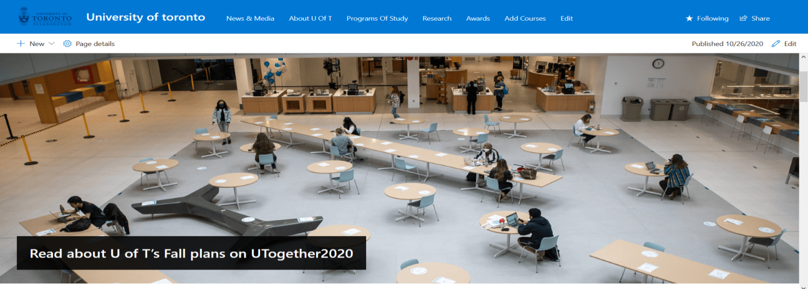

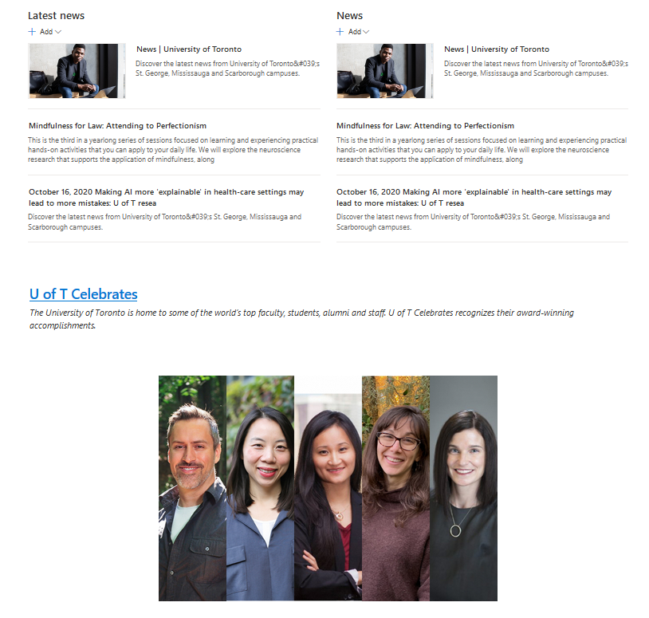

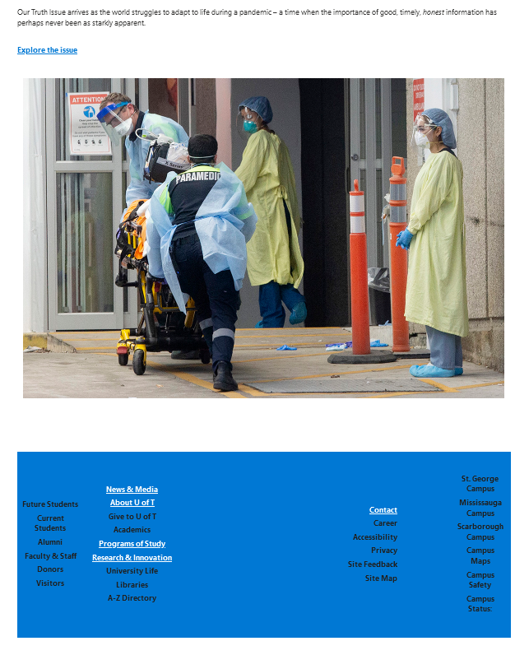

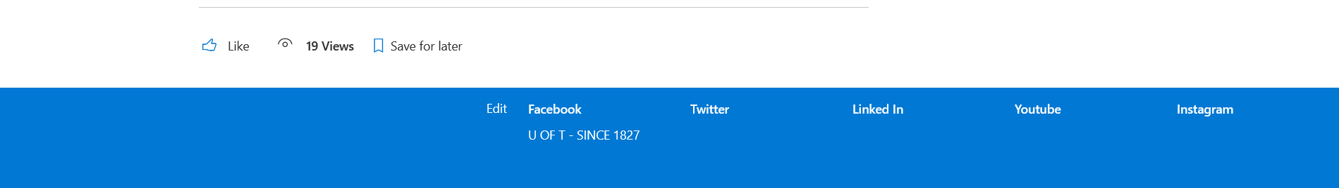

**News:**

This feature Contains the latest news, featured news and recent COVID-19 news of University of Toronto. Using the web part I have add these section.



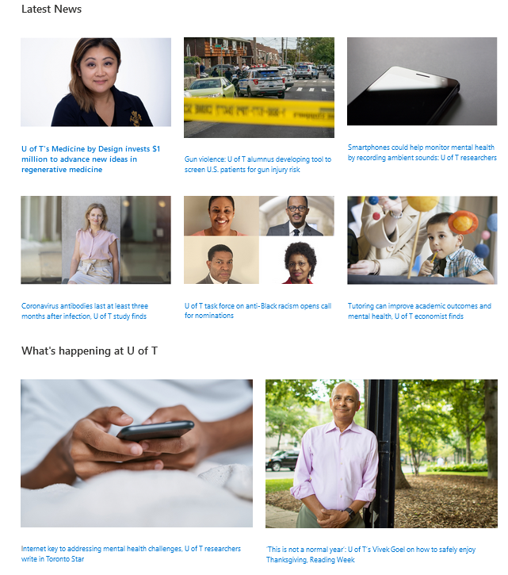

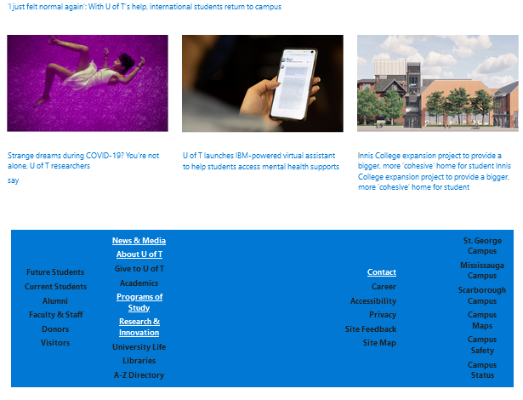



**About:**

About page contains the overview of the university such as informative video, priorities event and addressing the mentor.



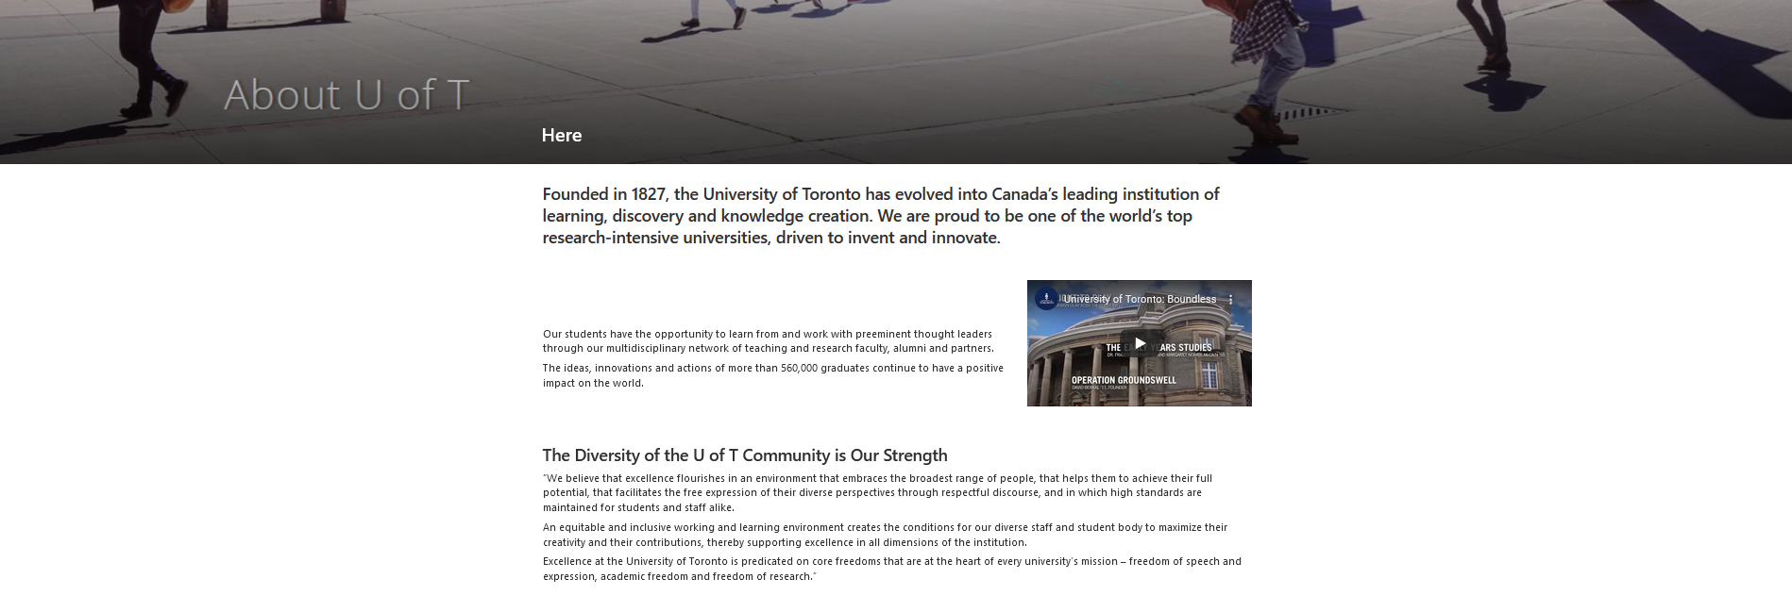

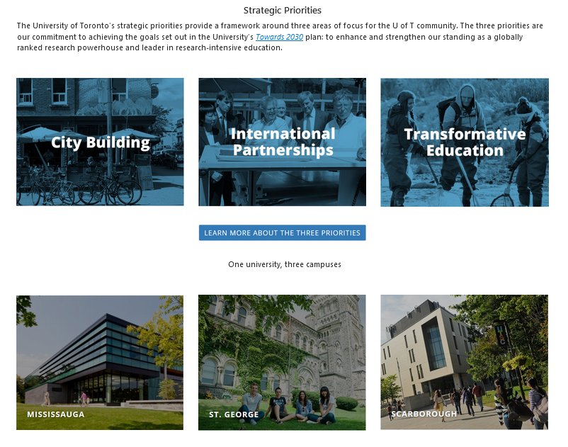



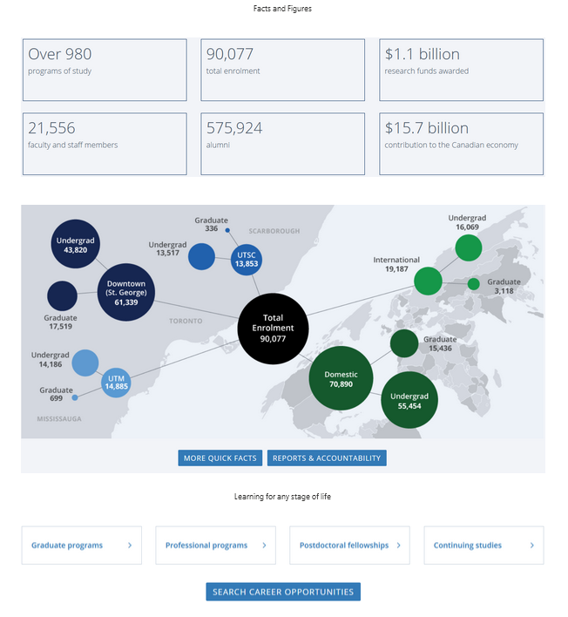

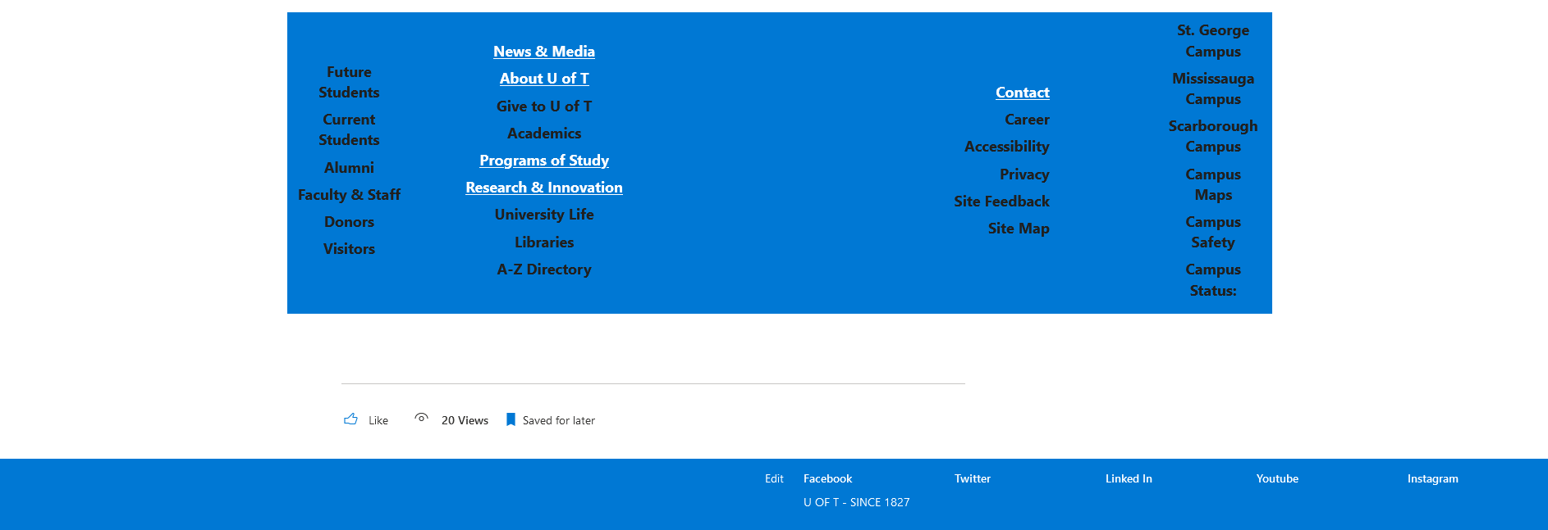

**Program of study:** Taking snapshot from the original site I have developed this section. Because generally SharePoint don’t allow to deploy such UI.



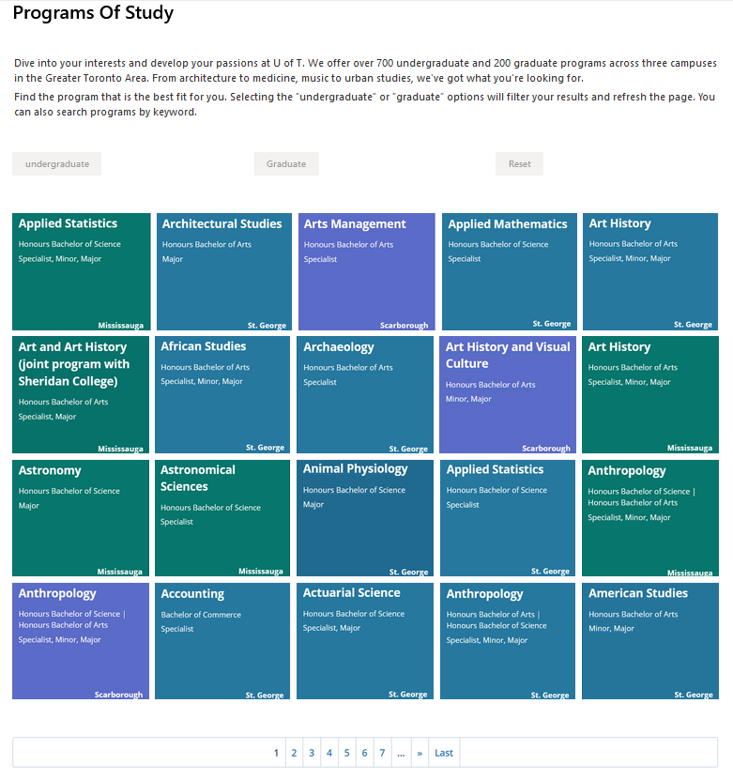



**Databases of the website:**

This shows the option to add new item that has given to scenario to connect an option to database. Customizing through Power apps I have create this form and the form data is stored in course list.

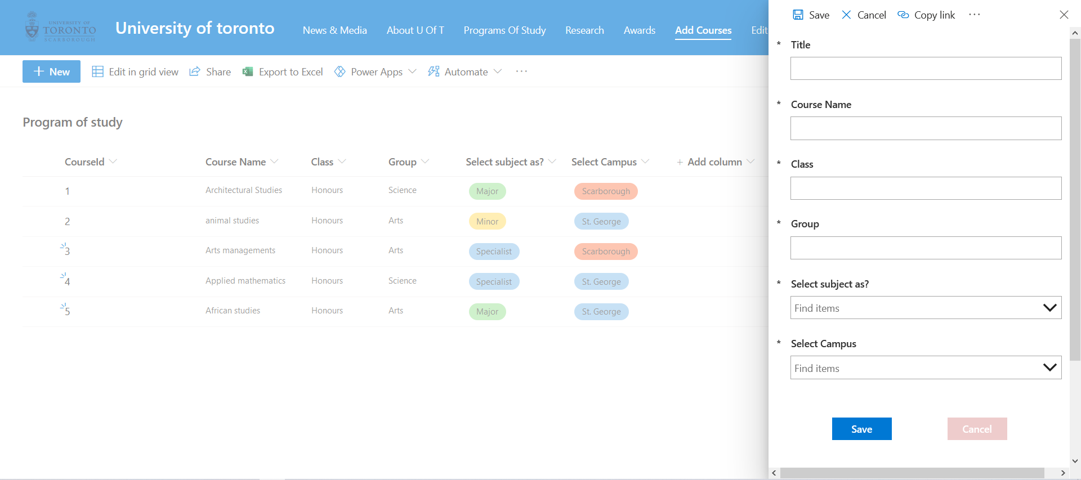

**Research news:**

Providing the research news and the video of the research activities. SharePoint allow adding individual video in different web part.



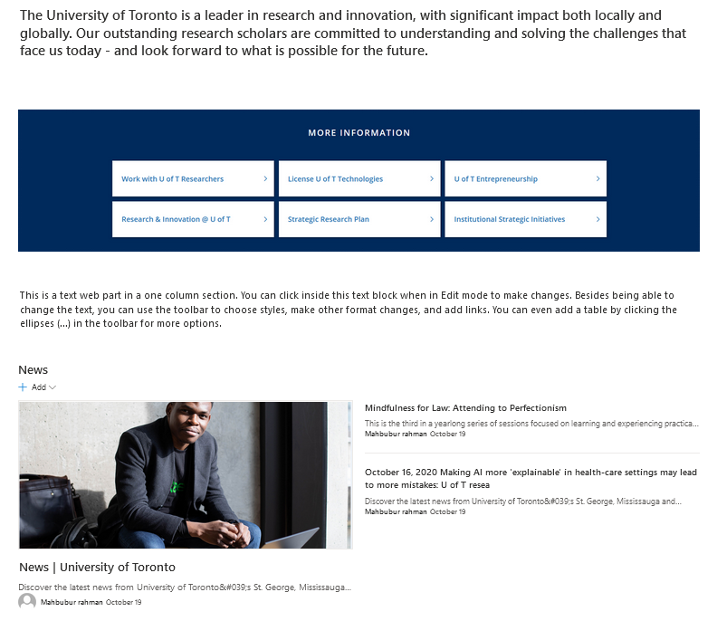

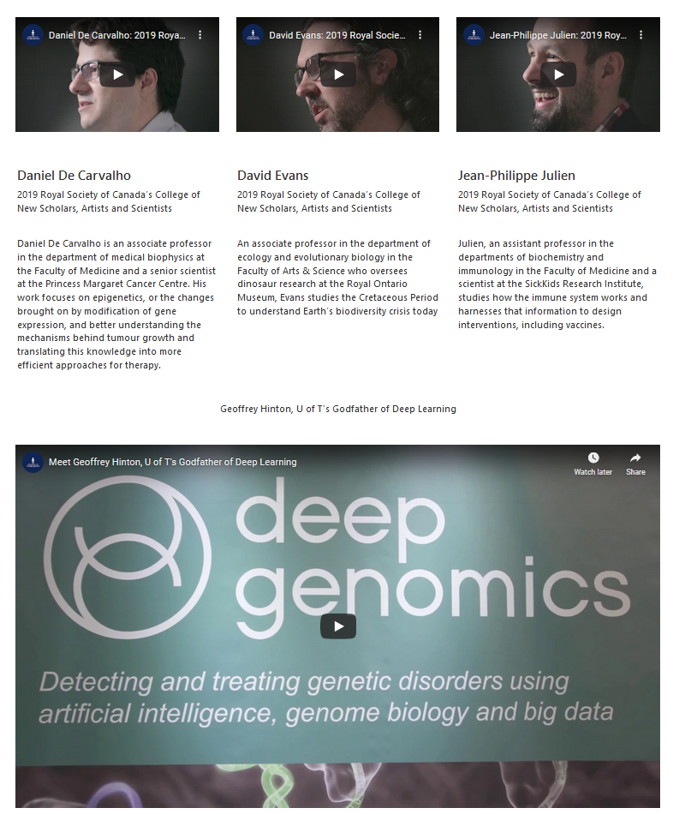

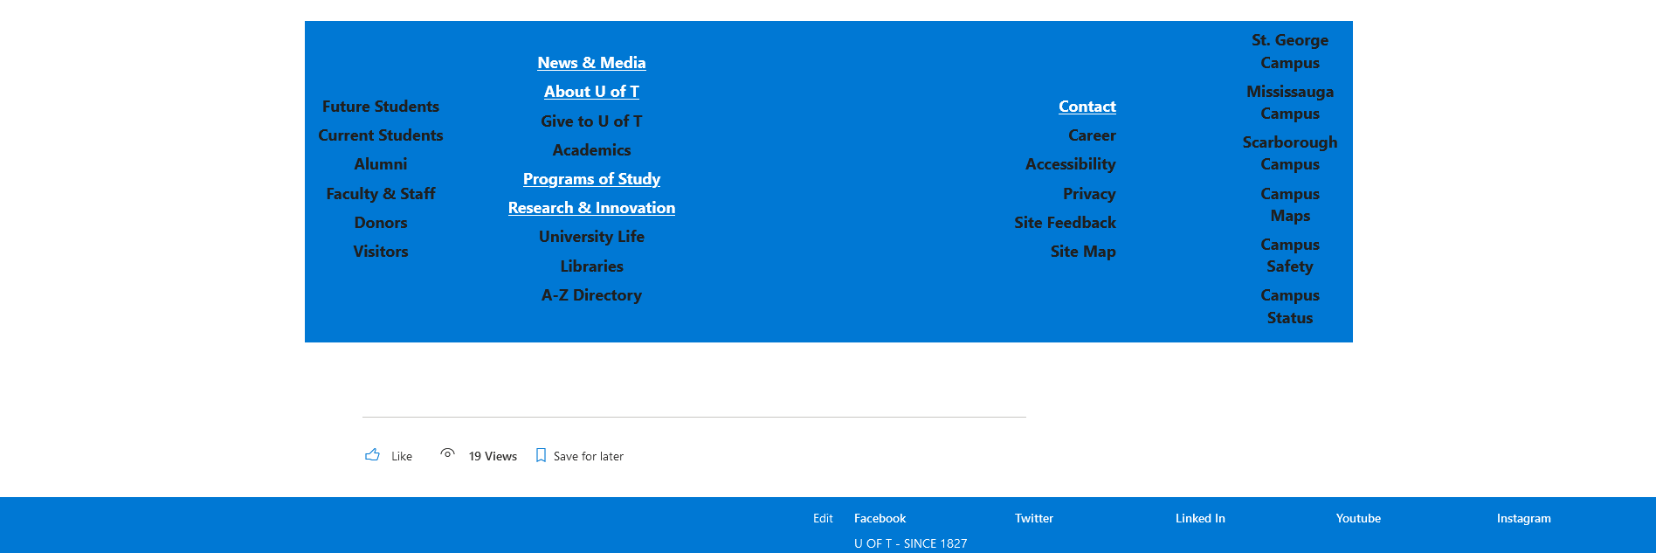

**Success stories of previous students:** This item shows the achievement of the previous student who are rewarded for their activities of own field.



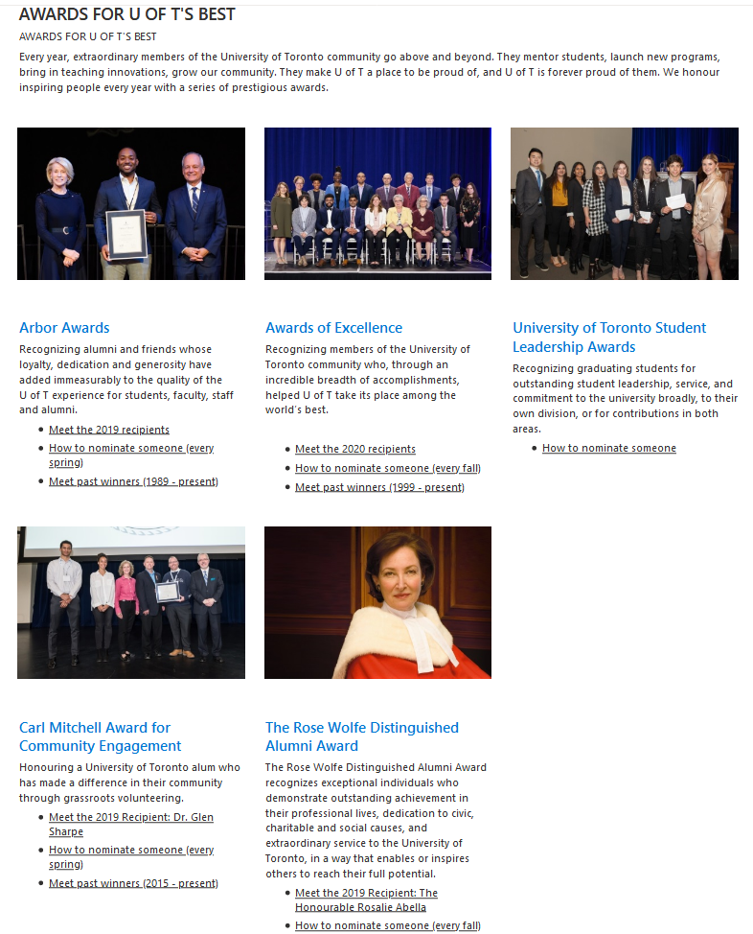



**Contacts Information:** Contact information shows the information for contacting with the authority for any individual reason. This option is implemented as like original site.

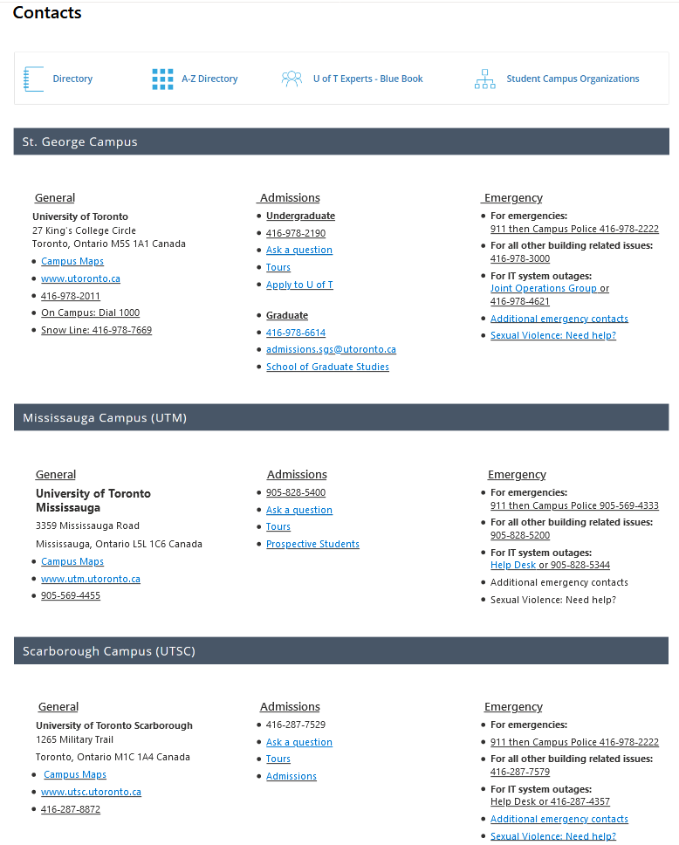



**Deal with inquiries:** By this form any student or guardian can ask any query to the authority. The responses will store in a list.

